**Name: Maria Khuzema**

**Id: BIT-23F-031**

**Semester: 03**

**Section: A**

**Course: AI**

**Lab: 07**

**Lab 07**

**Task 01:**

Write a Python function that draws square using asterisks (*). The side length of the square should be provided by the user**.**

**Code:**

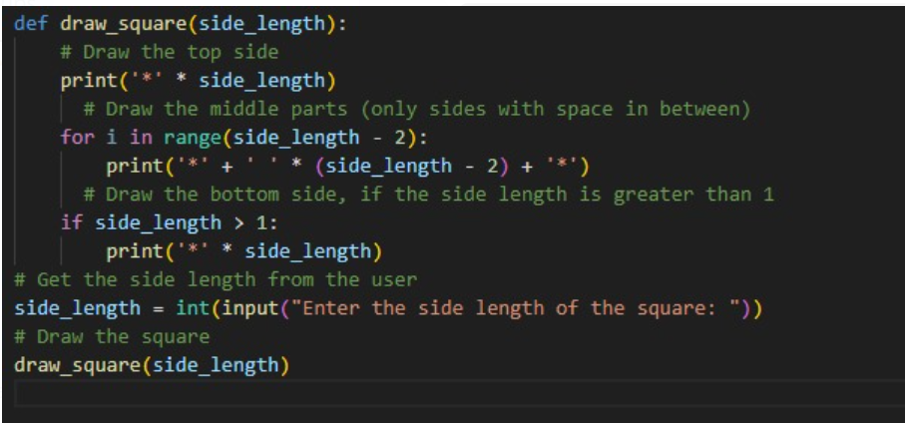

**Output:**

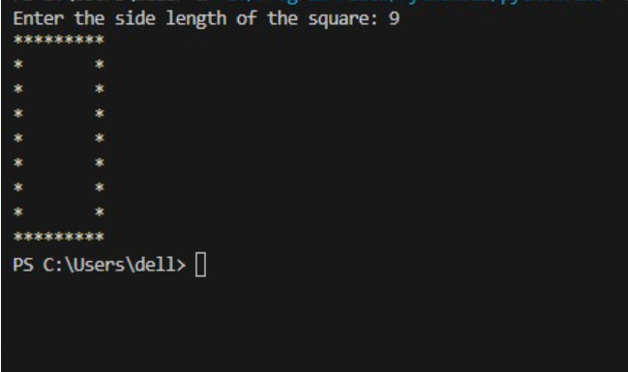

**Task 02:**

Write a Python function that takes a list of numbers as input and returns the sum of only the even numbers.

**Code:**

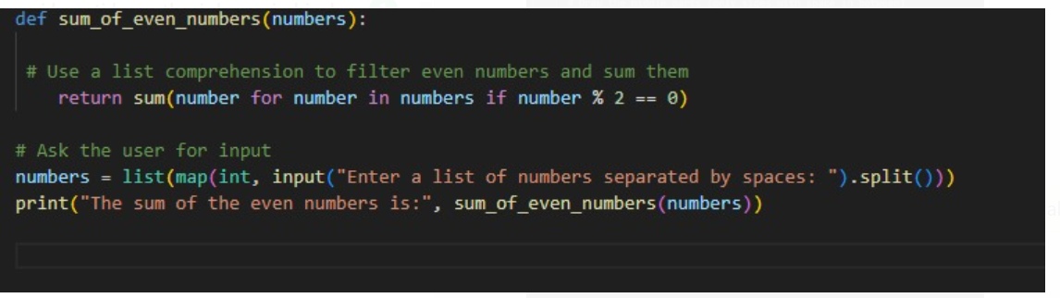

**Output:**

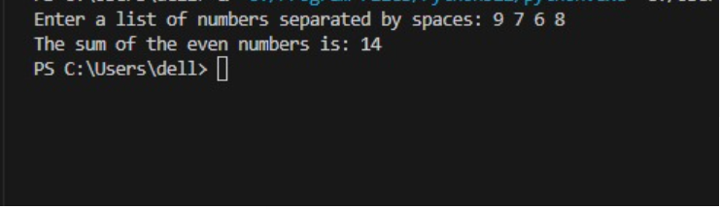

**Lab task 03:**

Write a Python function that takes a number as input and counts down to zero, printing each number.

**Code:**

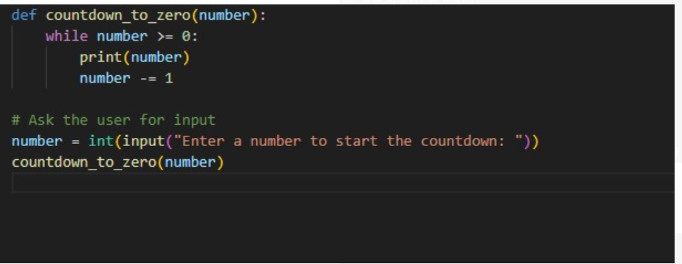

**Output:**

